|  |  |
| --- | --- |
| Crowdfunding Analysis & Recommendations for Fever  2021 |  |
|  |  |
| July 1, 2021  Data Analytics Boot Camp  Authored by: Tally Anter-Rupa |  |

# Supporting Fever – Crowdfunding Analysis & Recommendation

|  |  |  |
| --- | --- | --- |
| Purpose: This report is designed to providing historical analysis on past crowdfunding projects and through analysis provide recommendations based on the most successful outcomes using data provided. | | |
|  |  |  |
| Background: Louise has a funding short fall for her play Fever and has requested a report in order to measure the success of various campaigns based on funding goal and launch date .  The analysis was completed using crowdfunding data provided from May 17, 2009 to March 15, 2017. Raw data was analyzed in order to provide recommendations regarding most successful funding goals, campaign launch date and length of campaign with a focus on theater crowdfunding. | | |

## Analysis:

Crowdfunding data was analyzed in order to understand the success rates of campaigns based on funding goals and launch date.

**Campaign Launch Date:**

Campaign succuss was analyzed and measured based on launch date. The most successful month to launch theater crowdfunding campaign is assessed to be in May, when 111/166 campaigns launched were successful – this a success rate of 66.9%.

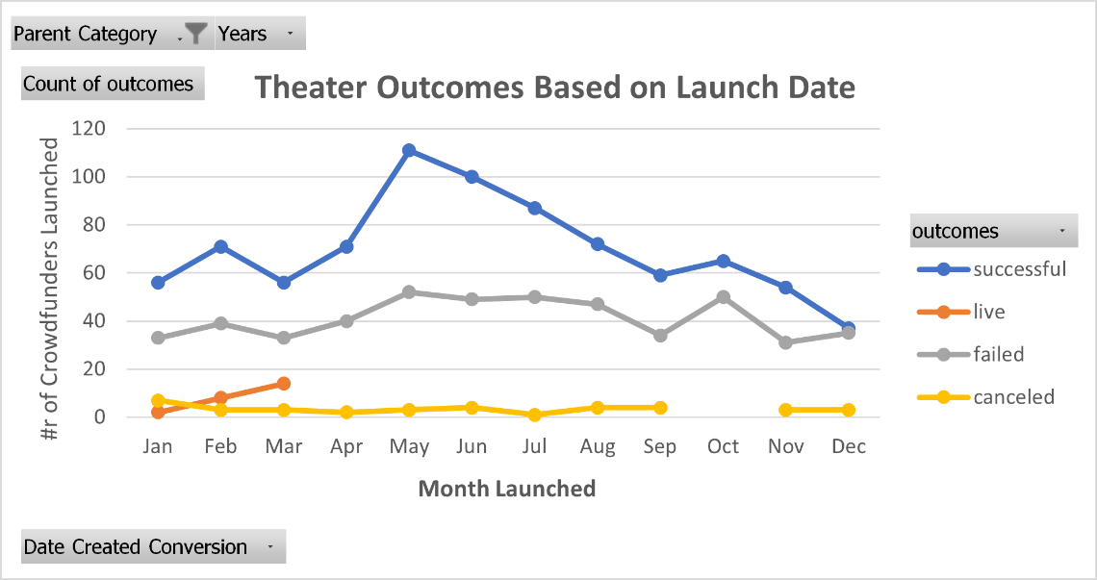

Recommended Goal:

The recommended goal for the Fever project is between $10,000 and $14,999, based on analysis of funding goal success of 84% - which is the highest success rate of all funding goals reviewed.

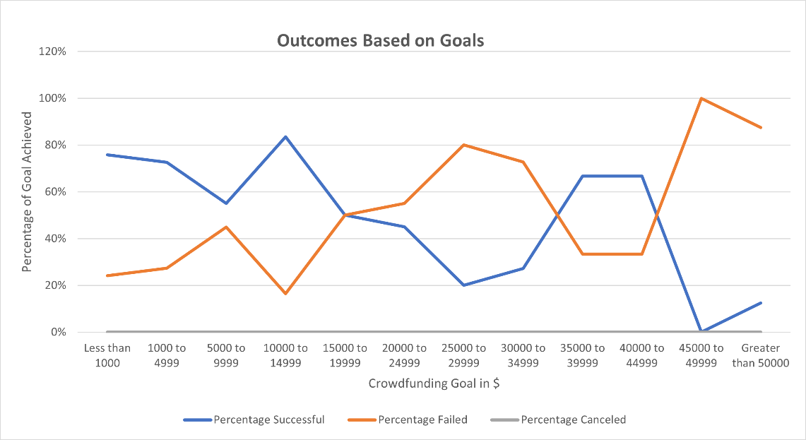

Additional Recommendations:

The average donation to successful crowdfunding theater campaigns was $82.16, indicating requesting smaller donations may make the campaign accessible to more donors.

Limitations:

There are several limitations to this report and analysis.:

1. Analysis is based on data provided and has not been verified
2. Data provided is based on information from 2009-2017. No data has been provided from June 2017 to present, in which time results and trends may have changed.

Challenges:

This analysis presented me with several challenges. The first of which was getting comfortable using Excel functions and ensuring the accuracy of my analysis. Several times when I analyzed the success and failure rates of Kickstarter campaigns based on goals, I realized that the results for each category seemed too high. I ran into a number of frustrations while working on the analysis and gained valuable insight. I have learned to give myself extra time to learn new skills, that taking a break can often result in insight in problem solving and that it is okay to get frustrated, but only if I can find a different angle from which to approach the problem.

I overcame my filtering by goal challenge by looking at the code and realizing that I had not properly inputted a filter for ‘Plays’. Once I added the additional command in the *f*Countif the results and graph corresponded to the sample in the Boot Camp challenge instructions.